Lab 8

Recursion and N-Queen Problem

# Introduction

This lab assignment you will write a JavaFx program for N-Queen Problem Game. You can apply the recursive function to solve the N-Queen problem in NQueen.java file. In this application, user can choose size of board between 2 to 20.

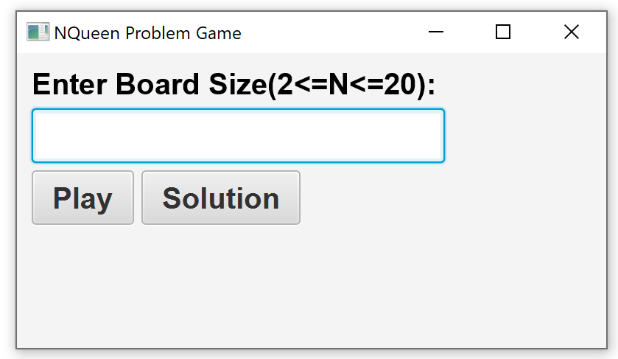

If the board’s size cannot solve, the program must show the dialog message by display “No Solution!!”.

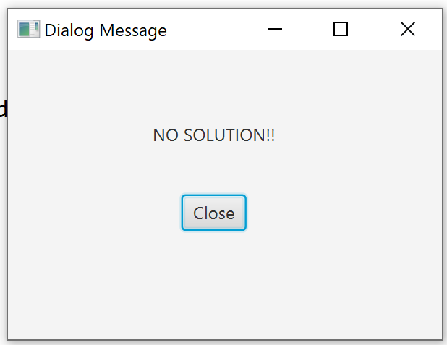

Otherwise, the board’s size can solve the N-Queen program. For example, the size = 4 user can click play button to play the 4x4 Queen Game.

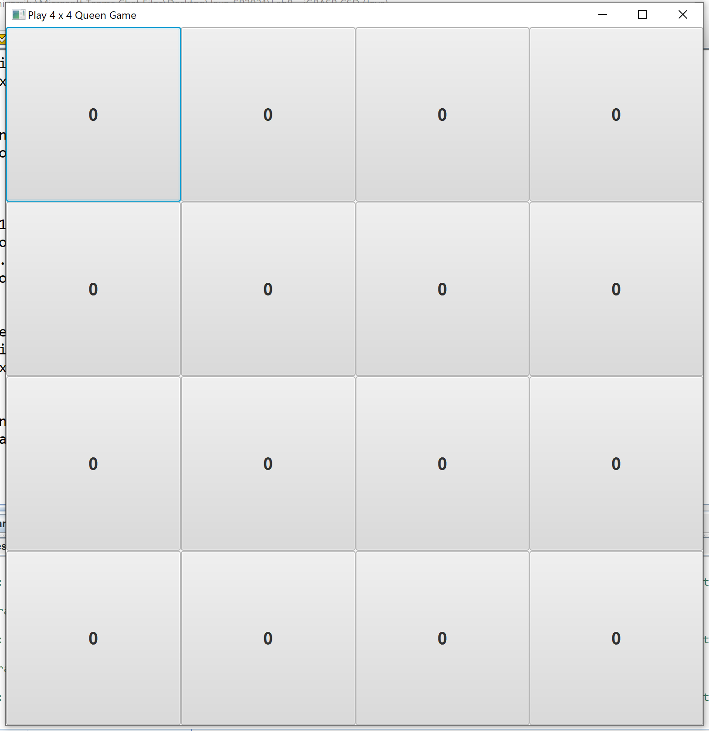

The user can select or unselect the cell on board to put the queen in the safe position.

# 

When user put all N queens in the all safe positions, the program must show dialog message shows “Well done, You did it!!”.

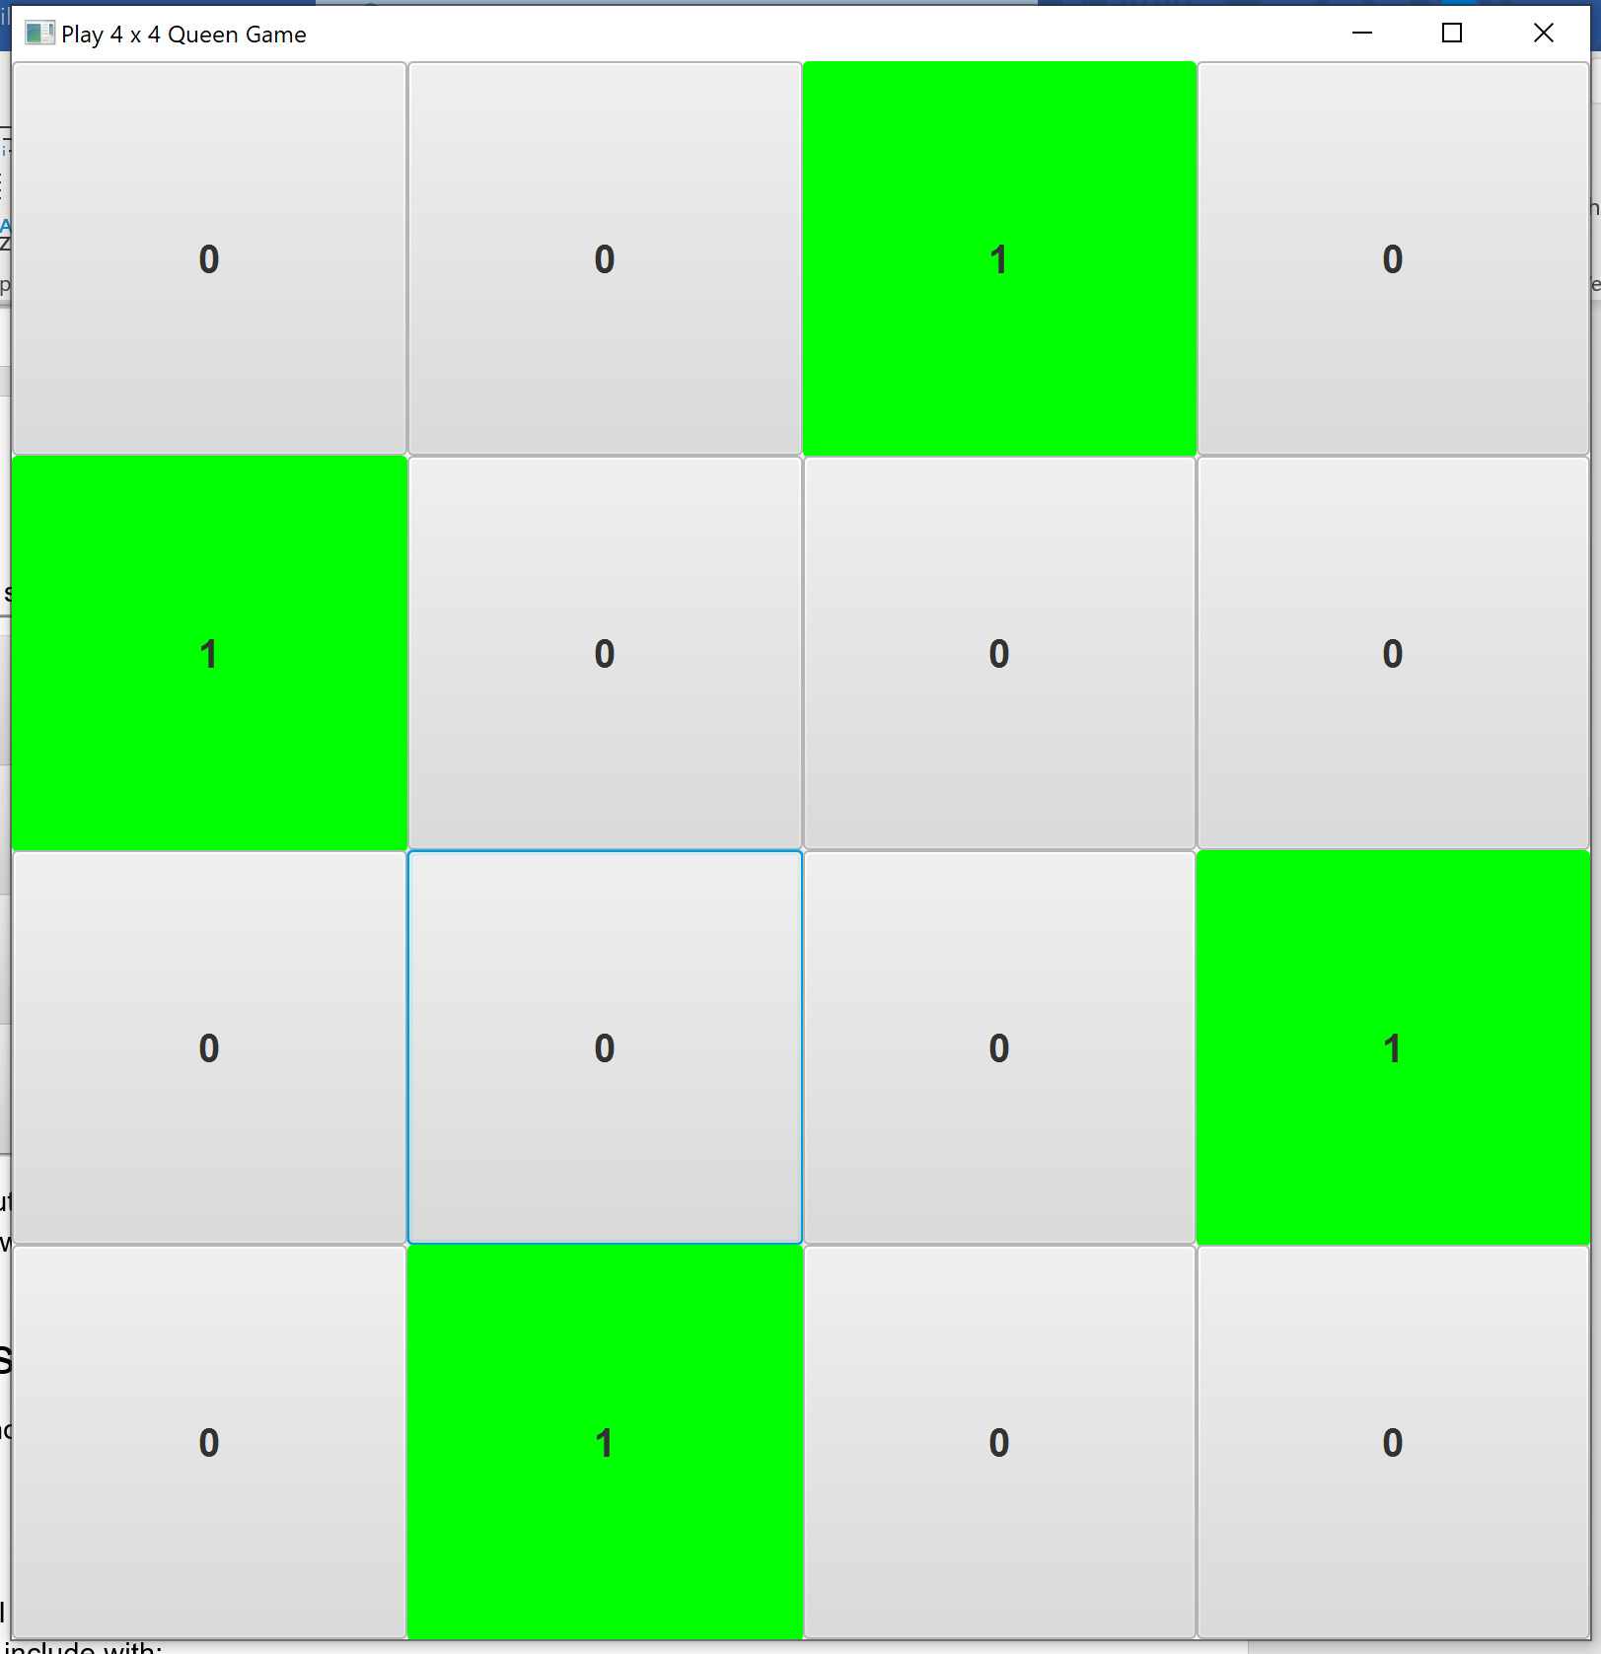

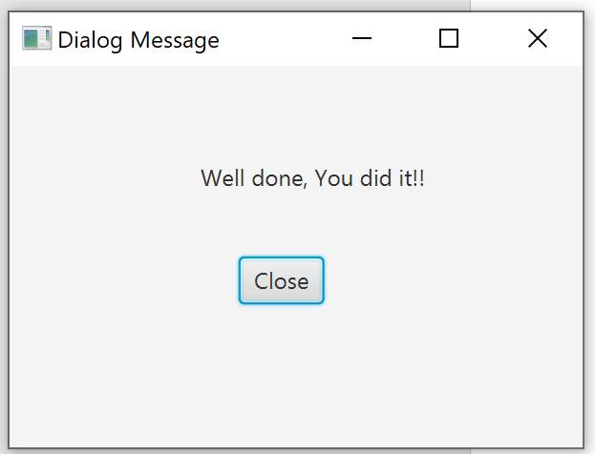

User can click the Solution button, for display the one of solutions in N-Queen problem.

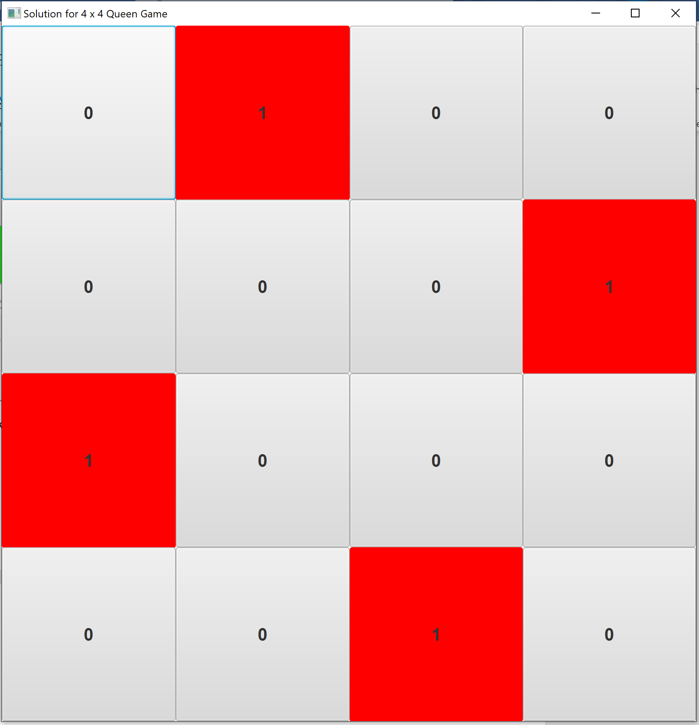

# Classes

All classes should be part of a package **nqueen**.

**NQueen.java**

This class was provided in the lab for solving N-Queen problem. You do not need to modify this class.

**PlayBoard.java**

You will develop this class for playing N-Queen Game. The professor will introduce how to code the game in lab.

**DisplaySolution.java**

You can adapt or modify the PlayBoard class to display the solution of N-Queen Game.

**NQueenGame.java**

The entry point of an application. The program should have label, textfield, play button and solution button as shown in the below figure.



# Submission

After completing this lab, zip up all the classes in the **nqueen** package and name of the zip file COP3809-LAB8-SYY-XXXX.zip ( YY = 01, 02, or 03 XXXX = Student ID) submit on Canvas.